

MBA672A

Adani vs Hindenburg

Submitted To: Submitted By: GROUP 5

Prof. Abhinav Tripathi (22125008) Adhish S

DIME (21125046) Mohd Rahim

IIT Kanpur (21104075) Puneet Shrivastava

(22125074) Rupesh Kumar (200841) Sairam Nayak Kunsoth

# Introduction

* 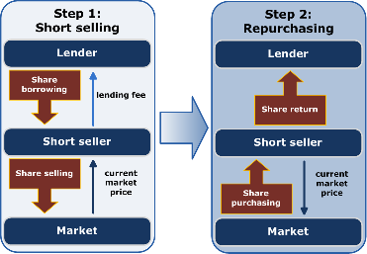Hindenburg -> Proﬁts from short-selling
* Self-created issues -> Fall of company stock prices
* Released a report on the Adani group
* A divided public opinion
* Hindenburg's motives for proﬁt should not be ignored
* It's important to read and understand the report

# Adani Group

* Leading Conglomerate in India founded in 1988
* Diversiﬁed into various sectors
* Adani Ports and Special Economic Zone
* Adani Green Energy
* 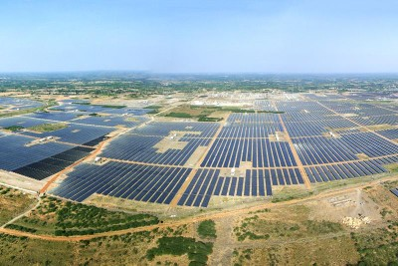Adani Enterprise
* Adani Total Gas
* Subsidiaries deliver impressive results

# Sucheta Dalal vs Adani

* Well known journalist: Exposed Harshad Mehta Scam
* Advocate for transparency & ethical business practices
* Exposure to Adani group: Importance of continued scrutiny and investigation by journalists
* Discussed on Social Media: Tweet linked to drop
* Rumors and speculation can impact stock prices: Be cautious
* Role of journalists
* Need for prudent investment decisions

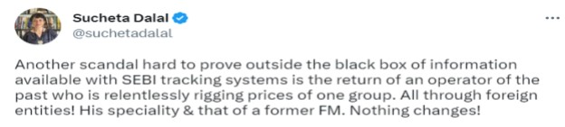

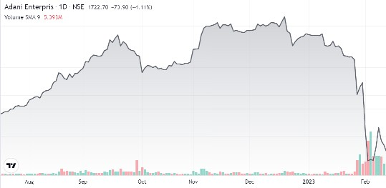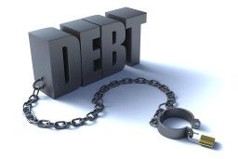

# The Report

* Generates public reports on frauds
* Track record of targeting companies with short positions
* Questions company’s fundamentals
* Suggests overvaluation
* Highlights extreme debt, lack of transparency
* Alleges Market manipulation, money laundering
* Use of inﬂuence to silence critics and media
* Open challenge to answer 88 questions

# Impact of Report

* Since the release of report, all adani stocks have fallen at least 25% with adani total gas getting a set back of upto 70%. (As on 13th February, 2022).
* Adani Enterprises FPO was cancelled in spite of it being oversubscribed 1.12 times. The stock has fallen over 50% since.
* Markets have been more volatile, nifty decreased by -2.84% on 24th Jan.
* Dow Jones has removed Adani Ports from its sustainability index(DJSI) and Adani Group companies bonds have hit distressed levels
* LIC (which has a stake in Adani) and SBI (has in excess of $2 billion loan to Adani Group), came under the scanner as both are public institutions.
* Chants in parliament about the alleged closeness of Gautam Adani and Prime Minister Narendra Modi.

# Exchange’s Response

* 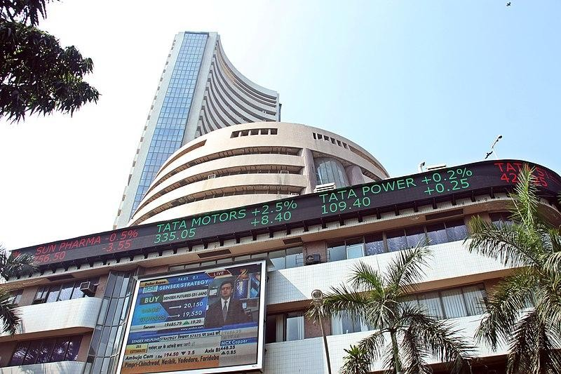Adani Enterprises' faced several trading halts on the Bombay Stock Exchange after the release of the report, and it eventually fell by 30% before cutting losses.
* Adani Green Energy Ltd. and Adani Transmission Ltd.'s circuit limits have been updated by the National Stock Exchange of India (NSE) to 5%. Circuit limits are established by stock exchanges to avoid signiﬁcant ﬂuctuations in stock prices occurring quickly.

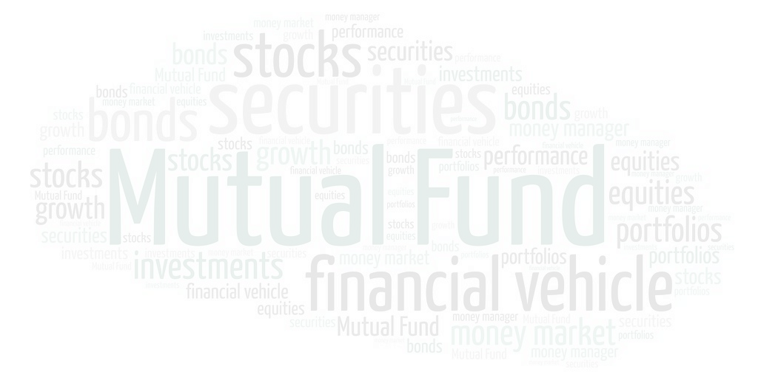

# Adani’s Response

* The investment funds, which controlled a sizable portion of the ﬂoat, were offshore corporations. Hindenburg reported, it spoke with former workers of the business that managed one of the funds, and they indicated that "Adani owns the shares."
* Hindenburg claimed that Amicorp, which was linked to the $

4.5 billion 1MDB affair in Malaysia, had relationships with Adani Group.

* Hindenburg has raised concerns about Vinod Adani, the brother of Gautam Adani, and the fugitive CA Dharmesh Doshi, who is accused of manipulating the stock market.
* The group stated in a number of responses to Hindenburg's other allegations that there were numerous related party transactions to privately held Adani companies, that the transactions were carried out on an arms-length basis.

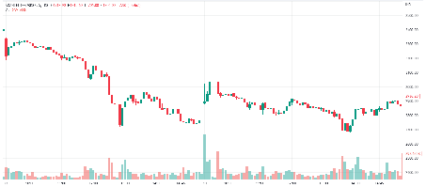 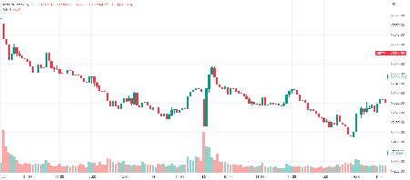

Adani Enterprises Stock NIFTY 50

* 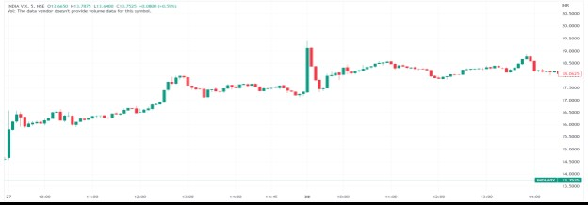For the all the allegations put forth by Hindenburg, the Adani team has refused these allegations and said we have been transparent to all our stakeholders about our company and we are in compliance with the Indian laws.
* The aftermath of Adani’s response witnessed volatility in the Adani Enterprises Stock as well as in the ﬁnancial markets (NIFTY 50).

# Analysis

* Allegations of accounting fraud and environmental infractions.
* Lack of ethics and transparency in the company's practices.
* Unethical practices can hurt a company's ﬁnancial performance and reputation.
* Importance of ethical conduct and transparency in business.
* Organizations should follow strict norms of transparency and accountability.
* The importance of crisis communication and reputation management.
* The charges may decrease the company's share prices and market value.
* Allegations of opaque related-party transactions indicate a lack of transparency in ﬁnancial reporting.
* The regulatory response raises concerns about potential risks associated with investing in the company.
* Security analysts need to take a holistic approach to assessing a

company's risks and beneﬁts.



# Conclusion

* Investors should exercise caution before investing in Adani Group.
* Adani Group has been involved in controversial projects
* Investors should assess the potential inﬂuence of regulatory measures on Adani Group's activities and investments in government-regulated industries.
* Adani Group's ﬁnancial health and stability should be evaluated
* The competitive environment in Adani Group's markets should also be considered before making any investment decisions.
* Investors must carefully evaluate Adani Group's track record and reputation in light of the Hindenburg Research report and controversies surrounding the company.
* Investing involves inherent risks, and investors should make decisions based on accurate data.

